Bibby Pioneer

Multi-purpose barge

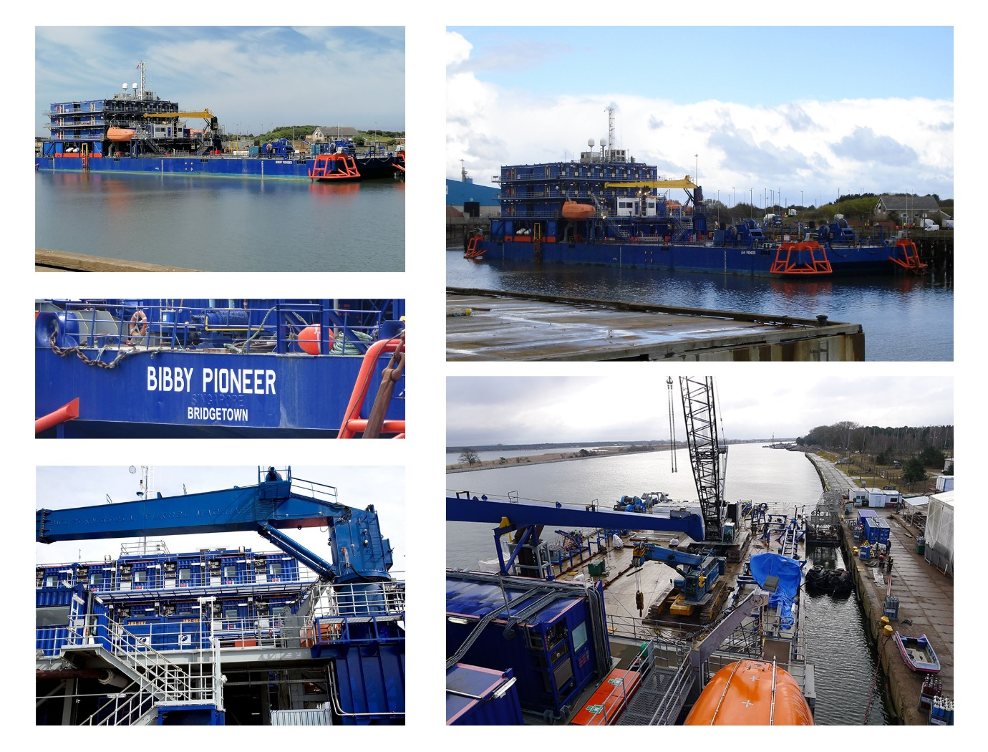

General Information

Type of Barge: | +A1, Barge + Notation ‘Accommodation Barge’
Port of Registry: | Bridgetown
Classification: | American Bureau of Shipping (ABS)
Built: | 2007, Nantong Tongcheng Ship Manufacturing Co. Ltd., modified 2010/11 in Glasgow UK
Length: | 100.6 metres
Breadth: | 30.48 metres
Depth: | 6.09 metres
Gross Tonnage: | 7599 tonnes
Net Tonnage: | 2279 tonnes
Deck Capacity: | 15 tonnes/m²
Free Deck Area: | 1,100m²
Fresh Water Capacity: | 1,360 m³
Fuel Oil: | 613 m³
Load Line: | International Load Line certificate issued by ABS
Main Generators: | 3 x 900 kW at 440 v 60 Hz 3 ph
Emergency Generator: | 1 x 900 kW at 440 v 60 Hz 3 ph
Mezz Deck Service Crane: | 7.5 tonnes at 25 metres maximum lifting capacity
Mooring: | 8 point mooring system, 4 x 100 tonne double drum winches equipped with 1100 metres x 58 mm wire, tension monitoring system and local and remote control facilities. 4 x 12 tonne primary anchors & 4 x 7 tonne secondary anchors
Gangway: | 2 position gangway port side
Boat Landings: | Port and stbd for CTV transfers
Rescue Boat: | Davit Launch rescue boat – Port side
Galley: | Fully equipped, state of the art, galley and mess room
Accommodation: | Serviced accommodation for up to 120 POB (upgradeable to 240 POB)

